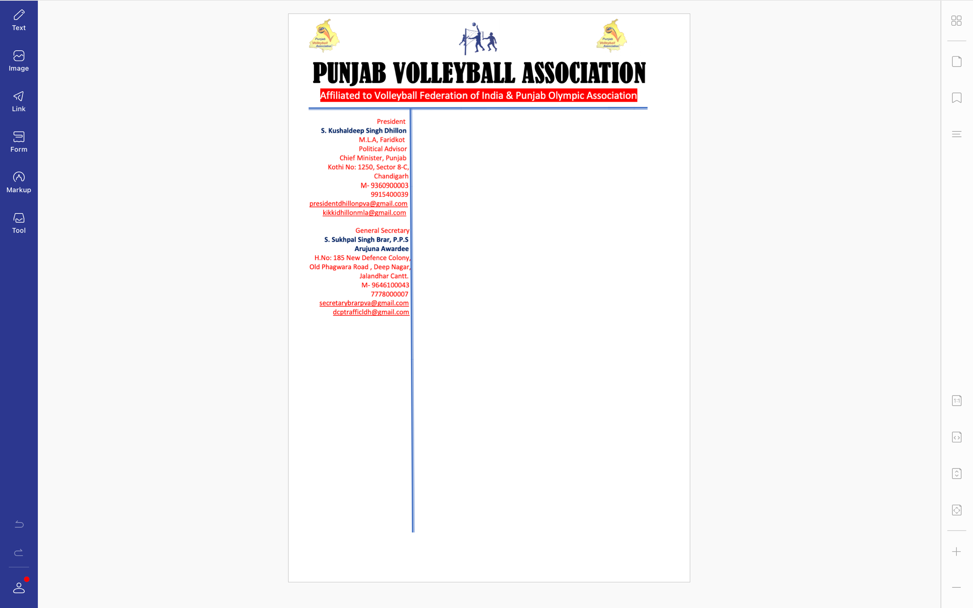



**Ref. PVA/BRAR/2021/Spl.-(2)/2921** Dated: 29-09-2021

v`l:

s. primMdr isG

izlwH Kyf APsr

biTMfw

ivSw: sInIAr styt vwlIbwl cYNpIAniSp (mrd Aqy AorqW) iv`c qknIkI kmytI sbMDI

auprokq ivSy dy sbMD iv`c Awp jI nUM bynqI kIqI jWdI hY ik

sInIAr styt vwlIbwl cYNpIAniSp (mrd Aqy AorqW) jo ik izlwH vwlIbwl AYsosIeySn, PrIdkot v``loN imqI 1,2 Aqy 3 AkqUbr, 2021 idn Surkvwr, SnIvwr Aqy AYqvwr nUM PrIdkot ivKy krvweI jw rhI hY [ ies tUrnwmYNtx iv`c Awp jI nUM bqOr qknIkI kmytI dw mYNbr inXukq kIqw jWdw hY Aqy bynqI kIqI jWdI hY ik auprokq ifaUtI iv`c smyN isr phuMcx dI ikrpwlqw kIqI jwvy[

DMnvwd sihq

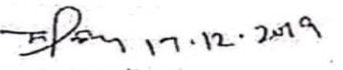

suKpwl isMG brwV, Arujnw AvwrfI

jnrl sk`qr

pMjwb vwlIbwl AYsoSIeySn